Unit 1. “My Skills and achievements contribute to the society itself”
Guía n° 5 AUTO EVALUACIÓN, English Language

Nombre: |  |  |  | Curso: | IIIrd | Fecha
Puntaje Evaluación |  |  | Puntaje de corte (60%):
Puntaje obtenido: |  |  | Calificación:

INSTRUCCIONES:
- Se puede enviar la guía realizada en formato Word o realizada en el cuaderno y le saca una foto. NO ES NECESARIO IMPRIMIRLA.
- ESTA GUÍA ES UNA AUTOEVALUACIÓN, NO TIENE NOTA. No se permiten guías copiadas de otros compañeros/as.
- La guía debe ser enviada vía mail hasta el día Martes 9 de Junio, a los siguientes correos:
III A y B: Daniela.moreno@elar.cl
III C: francisca.ipinza@elar.cl

Objetivos: Reconocer y relacionar ocupaciones.
Contenidos: Occupations.

- Read and choose the correct alternative, according to the job description.

1) I deliver letters and packages to your home. a) Postman b) Letter man
2) I wear a uniform a badge. I keep your neighborhood safe. a) Lawyer b) Police officer
3) I take care of sick animals. a) Vet b) Doctor
4) I work in a school and I help people learn a) Teacher b) Lifeguards
5) I work in an office. I type letters and answer the phone. a) Accountant b) Secretary
6) I go to court and defend people’s rights. a) Teacher b) Lawyer

2. - Read and answer the following question using vocabulary knowledge.
1. What does an “architect” usually design?  a) Buildings  b) Clothes  c) Cartoons  d) Boats | 2. Which of the following things can you get from a “postal man”?  a) a letter.  b) a job  c) money  d) a cup of coffee
3. Where does an “astronaut” usually work?  a) in an office  b) on a mountain  c) under water  d) in space | 4. Which of the following should you bring to a “veterinarian”?  a) your friend  b) your cat  c) your cellphone  d) your homework
5. Which of the following things can a “mechanic” fix?  a) a television  b) computer  c) a car  d) a door. | 6. Where does a “doctor” usually work?  a) Pharmacy  b) Hospital  c) In an office  d) Supermarket
7. Which of the following things can a “plumber” fix?  a) a window  b) a chair  c) shoes  d) a sink | 8. Which of the following things can you get from a “librarian”?  a) chocolates  b) clothes  c) books  d) tickets

3. Read the following occupations and choose the correct alternative for each picture.
1
3
  2  a) Journalist  b) Cameraman  c) Doctor  d) Actor |   a) Doctor  b) Maid  c) Nurse  d) Painter
  4  a) Cashier  b) Postman  c) Cook  d) Banker |   a) Mechanic  b) Gardener  c) Dustman  d) Plumber
  5  a) Butcher  b) Gardener  c) Sculptor  d) Cook | 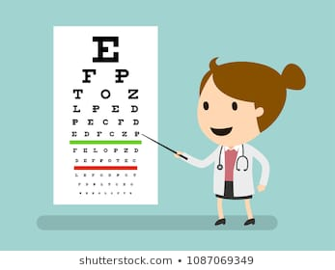  6  a) Optician  b) Doctor  c) Nurse  d) Veterinarian

